*Title*: Wildlife crossing structure size, distribution, and adherence to expert design recommendations

*Author Line*: Liam Brennan1,2, Emily Chow2, Clayton T. Lamb3*

*Author Affiliation*:

1University of British Columbia, Vancouver, British Columbia, Canada

2Ministry of Forests, Lands, and Natural Resource Operations and Rural Development, Cranbrook, British Columbia, Canada

3University of British Columbia, Kelowna, British Columbia, Canada

*Corresponding Author*:

Clayton T. Lamb

Box 7041

Fernie, British Columbia, Canada

V0B-1M7

P: 778-215-0334

E: [ctlamb@ualberta.ca](mailto:ctlamb@ualberta.ca)

**DATA AVAILABILITY**

All code and supporting data to reproduce this analysis in its’ entirety can be found at **CL will add github link later**

**Abstract**

Wildlife crossing structures and exclusion fencing have proven to successfully reduce animal vehicles collisions while still allowing for connectivity across roadways. Reduced animal mortality and sub population connectivity play crucial roles in the successful management of at-risk and culturally important species as well as holistic landscape stewardship. As large economic investments, that remain on the landscape for many decades, governments and planning agents strive to build cost-effective structures with the greatest positive impact on local wildlife. Scientists generally suggest that overpasses are at least 50 meters wide, with some recommending up to >100 m, to provide an ideal width for large mammal crossings. Optimal width can also depend on structure length, with longer structures requiring additional width, leading experts to suggest a width to length ratio of 0.8. We sought to assess how these recommendations manifested in practice, where agencies use this information to design structures and build structures while also balancing costs and logistical challenges. Internationally, countless wildlife crossings have been constructed to reduce the negative impacts of roadways that bisect landscapes. Included in our review was a sample of 83 overpass located in North America, Europe and Asia. This review found that the average width of wildlife overpasses is 45.8m, less than the width generally recommended by scientists. Further, the width to length ratio was 0.69, also lower than recommendations. As found in many studies, greater overpass width encourages greater overpass use, but increased width often comes with escalating building costs. As we show here, agencies are likely using the minimum widths as their initial target, and then settling on a smaller width once financial and logistical constraints are considered. Overpass width is an important aspect of crossing success for sensitive species such as grizzly bears and elk who tend to be very selective in terms of wildlife crossing structure choice. We recommend that agencies continue to strive for minimum overpass widths of 50m, and width to length ratios of 0.8.

**Introduction**

Roads provide essential connection corridors for people and goods across the world but can be challenging features for wildlife to cross safely and have myriad of environmental consequences (Clevenger and Huijser 2011). Decades of research have shown that roads can degrade and fragment habitat, create barriers to animal movement and be a major source of animal mortality (Clevenger and Huijser, 2011). Especially when considering large mammals who require very large home ranges, reduced dispersal because of roads may lead to lower colonization rates of patches, potentially reducing genetic diversity and population viability (Kusak et al. 2009; Sijtsma et al. 2020). Under the increasingly apparent stresses of climate change, animal mortality from Wildlife Vehicle Collisions (WVCs) and reduced dispersal abilities may present exacerbating threats to wildlife (Lister et al. 2015). Creative solutions that keep people and wildlife safer on roadways, especially on highways, are needed.

An increasing popular solution is the construction of wildlife crossing structures (Sijtsma et al. 2020). Wildlife crossing structures reduce wildlife mortality from WVCs (Kintsch at al. 2021), while still promoting road permeability (National Academies of Sciences, Engineering, and Medicine, 2008). These structures are often met with little to no public resistance because they increase motorist and wildlife safety without altering the flow of traffic. In fact, when wildlife crossing structures are paired with adequate wildlife fencing, studies have found up to a 92% decrease in reported WVCs (Kintsch et al. 2021). For example, in Banff National Park, a series of crossing structures and fencing along an 82 km section of the Trans Canada Highway reduced wildlife collisions by 80%, and reduced collisions with common species such as deer and elk by over 96% (citation?).

Wildlife crossing structures can be subdivided into two classes: underpasses and overpasses which respectively allow wildlife to cross under or over the roadway (Clevenger and Huijser 2011). Many highway WVC mitigation projects employ both structure types to promote roadway permeability for the greatest number of species (Huijser et al.;Clevenger and Waltho; 2000, Cramer, 2012). Clevenger and Huijer (2011) suggest that large wildlife overpasses are an optimal crossing structure choice for the greatest variety of species. Furthermore, various carnivores and ungulates (ex: bears, moose, wolves, lynx deer, elk and desert bighorn sheep) have shown preference for large, open overpasses compared to more constricted underpasses (Ament et al. 2021; Clevenger and Waltho, 2005; Kusak et al., 2009). Specifically, when standardized for number of structures and days monitored, Kintch et al. 2021, found there where approximately 4.8 times more successful mule deer passages on overpasses compared to underpasses. However, underpasses cost less and can used in between overpasses to pass some animals, and can be an effective part of an overall crossing system which includes both types of structures connected by fencing along stretches of highways. A mix of underpasses and overpasses can also be ideal as some animals, especially smaller and more cryptic species, prefer underpasses for crossing, while larger mammals often prefer more open structures such as overpasses and large underpasses.

For the purposes of this study, we focus on wildlife overpasses, which are defined as all above grade structures that cross over roads and/or other human infrastructure. Similar terms used in literature include landscape bridges, green bridges and ecoducts. Wildlife overpasses are often preferred by a greater number of species than underpasses (Clevenger and Huijser, 2011) but often also cost significantly more (McGuire and Morrall, 2000). Both peer-reviewed literature and handbooks for transportation practitioners suggest that overpasses designed for large mammals should be at least >50 meters to optimize crossing rates and structure costs (Clevenger and Huijser, 2011; Pfister et al.1999 in Renard et al. 2008). Overpass width is an important design consideration because wider overpasses create more open and natural crossing areas for many large mammals, as opposed to narrow crossings that may deter crossings if animals feel uncomfortable and hesitant to cross. However, wildlife overpasses are costly structures, often $5-15 million dollars, and wider structures cost more than narrower ones. Transportation agencies thus attempt to build structures whose dimensions satisfy the ecological role the structures are designed to support while delivering the project in a cost-effective manner.

A growing body of research suggests that large mammals prefer to cross on overpasses that generally exceed 50 meters wide. Ford et al. (2017) suggests that large overpasses >50m in width serve as crucial passages for family units of Grizzly Bears whose survival is crucial to population viability. Also, in Banff National Park, more generally, elk, grizzly bear, wolf and deer passage rates were positively linked to structure width (Clevenger and Waltho, 2005). Similar evidence from Pfister et al. (1997) suggests that crossing structures in Europe that were less than 20 meters were used significantly less than wider structures, and that 50 m should be considered a minimum width for large mammal overpasses. Building on these empirical studies, Clevenger and Huijer 2011, recommended large mammal overpasses to be 50-70 m wide over 4 lane highways. As pointed out Pfister et al. (1997), ideal widths must also consider the length of the structure, where exceptionally long structures may require width beyond the >50 m recommendation. The European Transportation Handbook addresses this consideration by recommending width to length ratios >0.8 for overpasses.

With increasing global support and investment in wildlife overpasses, there is a need to assess whether these evidence-based recommendations are reflected in overpasses being built. To address this question, we conducted a literature review to assess where wildlife overpasses have been built across the world and assessed the length and width of each against the expert design recommendations.

**Methods**

***Literature Review and Identifying Overpasses***

Over a two weeklong period, a literature review was conducted to locate and identify overpasses around the globe. Key words included “wildlife overpass”, “eco-duct”, “green bridge”, and “wildlife crossing structure”. The search engines Google, Google Scholar and the search engine embedded in Google Earth were used to collect pertinent peer-reviewed literature, government reports, websites, and overpass locations. Supporting information from these sources was used to locate the structures in Google Earth Pro 7.3.4.8248. All overpasses were included in the review if they were visible on Google Earth Pro, if they had distinct start and endpoints, if they appeared to be built with the intention of crossing large-bodied mammals and if sufficient supported information was available in order to locate the structures.

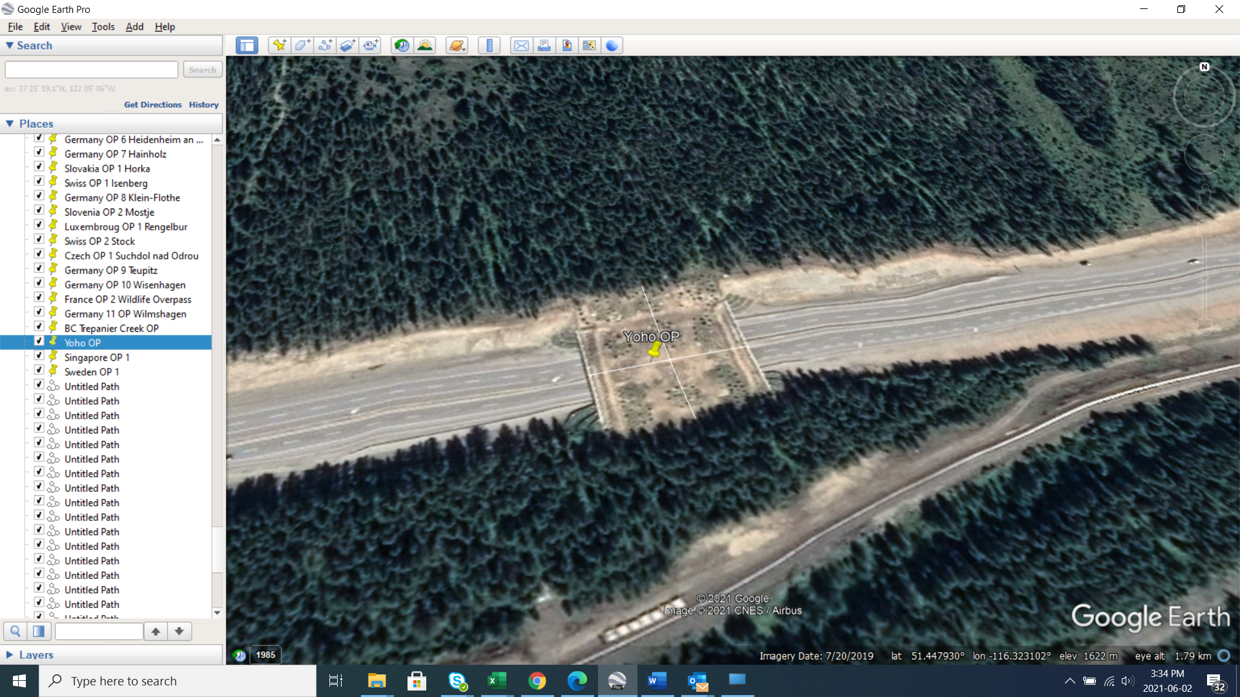

**Figure 1: An example of the process used to to measure overpass dimensions in Google Earth Pro. Shown here is the** Yoho National Park Overpass in British Columbia. The white lines represent the structure dimensions (N/S = Width, E/W = Length), which are measured using the path tool.

***Measuring Dimensions***

The width and length of overpasses was estimated using the path tool in Google Earth Pro 7.3.4.8248. Harrington et al. 2017 compared Google Earth Pro path measurements to physical measurements of road features and found an average error rate of 1.45% for on-road features, supporting the use of Google Earth Pro as a scientific measurement tool. We also tested the accuracy of the path tool on objects of known length, 91.44 meter (100 yard) long football fields, to assess reliability. Across 20 NFL and NCAA football fields, we found an average error rate of 0.2% (see Appendix A). The width of overpasses was measured based on the “usable” width over which animals could pass at the narrowest, center point of each structure (Figure 1). The length was estimated by measuring the distance between the natural topography “breaks” where the landscaped structure meets the adjoining piece of land (Figure 1). Because elevation change along structures is minimal it was assumed to have a negligible effect on measurement.

Figure 2. A) Map of the 83 large mammal crossing structures found in the literature review. Two clusters of overpasses were found in B) western North America, and C) Europe and western Asia.

**Results**

We identified 83 individual wildlife overpasses across the world (Figure 2). The majority of the 83 wildlife overpasses were concentrated in northern latitudes (n=77) (Latitude >40 **°**

) and amongst the wealthier nations in the world such as Canada (n=9), United States(n=13), Germany (n = 10), Holland(n=28) and Croatia (n=5).

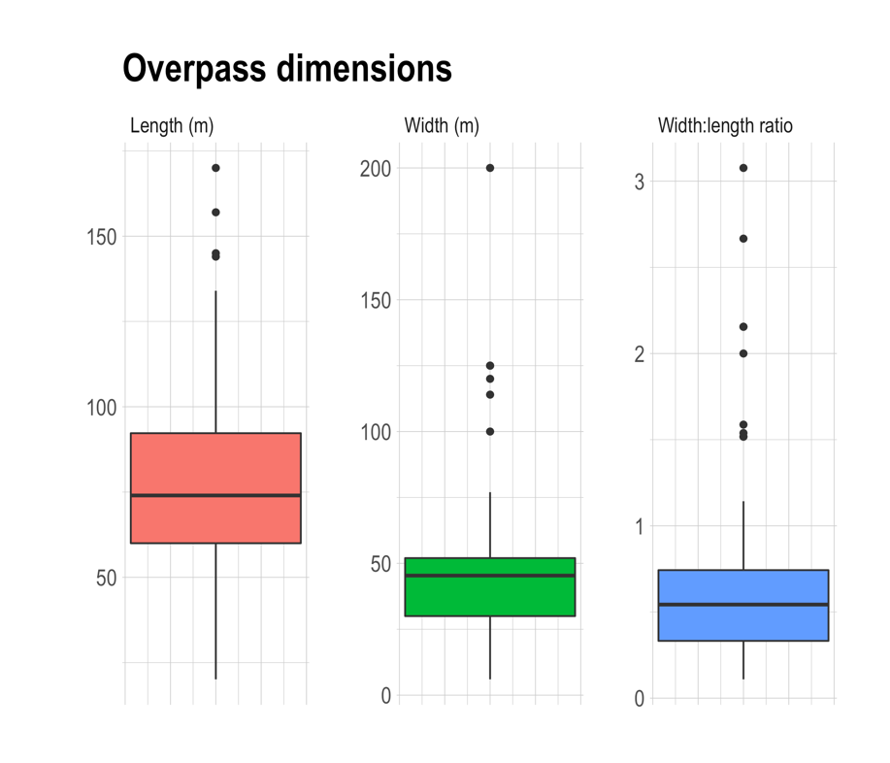

**Figure 3:** The distribution of widths of wildlife overpasses. 83 Wildlife overpasses were included in the review.

All structures were built between 1986-2018 and target the conservation and passage of ungulates and/or large carnivores. Across the 83 overpasses, the average width was 46m, an average of 4 lanes were crossed, and an average width to length ratio of 0.68 was observed (Table 1). Figure 3 shows the distribution of overpass width’s that highlights a slight skew towards larger widths along with some prominent outliers. The Croatian overpasses account for all the outliers with exceptionally large widths (>100m). The overpass with the smallest width (6m) in this subset was the first overpass built in Canada in 1990, the Trepanier Creek Overpass in British Columbia**.** The average dimensions for constructed overpasses fell below the expert-recommended width of > 50 m for 63% of structures sampled (n=52), and below the recommended width to length ratio of 0.8 for 77% of structures sampled (n=64).

As seen in Table 2, the literature review located 4 major overpasses that cross both a roadway and a railway. Qualitatively, these structures were generally wider and longer than those that did not include railways.

**Table 1**: Parameters of major wildlife overpasses and underpasses across the globe. Range shown in brackets.

|  |  |  |  |  |
| --- | --- | --- | --- | --- |
|  | **Mean Width to Length ratio** | **Mean Width (m)** | **Mean Length (m)** | **Mean number of lanes spanned** |
| **All Sampled Overpasses (n=84)** | 0.68 (0.11-3.08) | 46 (6-200) | 80 (20-170) | 4 (0-9) |
| **North American Overpasses (n=22)** | 0.69 (0.11-1.52) | 40 (6-60) | 66 (20-116) | 4 (0-9) |
| **Europe and Asia Overpasses (n=62)** | 0.67 (0.13-3.08) | 48 (10-200) | 84 (21-170) | 4 (2-8) |
| ***Expert Recommendation*** | *>0.8* | *>50* | *-* | *-* |

**Table 2:**  Wildlife overpasses that are built over both a road and railway. See **Appendix B** for Google Earth images of overpasses that cross both roads and railways.

|  |  |  |  |  |  |  |  |
| --- | --- | --- | --- | --- | --- | --- | --- |
| **Country** | **Name** | **Lat** | **Long** | **Width (m)** | **Length (m)** | **Number of Roadway Lanes** | **Number of Railway tracks** |
| Belgium | Wuustwezel Ecoduct | 51.41321 | 4.70194 | 60 | 134 | 5 | 2 |
| Holland | Noordnout Ecoduct | 52.06557 | 5.32468 | 53 | 96 | 6 | 2 |
| Holland | Hulshorst Ecoduct | 52.34611 | 5.71477 | 52 | 145 | 4 | 2 |
| Switzerland | Stock wildlife crossing | 47.16354 | 7.30771 | 74 | 82 | 2 | 2 |
|  |  |  | **Mean** | 59.8 | 114.3 | 4.3 |  |

**Discussion**

Our review revealed that wildlife overpasses have been constructed in many countries across the world over the past forty years. In total we identified 83 structures that were distributed between North America, Europe, and southeast Asia, predominantly in wealthier, northern latitude countries. These structures were primarily built to allow safe passages of large mammals such as deer, elk, moose, wolves, and bears, of which most structures were successfully allowing such passages after construction. As reviewed by ﻿Rytwinski et al. **(2016)** the crossing systems that these overpasses were a part, which also included exclusion fencing and underpasses, have been successful in reducing collisions between wildlife and vehicles by over 80%. Comparing the built dimensions of overpasses to expert recommendations, we found that wildlife overpasses were generally built slightly below the minimum standards recommended by experts. The goal of these standards is to facilitate overpass designs that are effective in achieving sufficient crossings of target species and providing adequate conservation return on infrastructure investments.

*Adherence to expert-based recommendations*

While the length of an overpass may largely be decided by the width of the road and local topography, we found that overpass widths can range between 6-200m and are generally decided based on expert recommendations for dimensions best suited to allow passage of target species and cost constraints. The average overpass width falls within the recommendations laid out by the European Transportation Agency (COST 341 Handbook) (40-50m) but outside of recommendations from Clevenger and Waltho 2011 and Pfister et al.1999 in Renard et al. 2008 (50-70m). In Banff NP, Clevenger and Waltho 2005 investigated the structural attributes of 13 different crossing structures, in relation to species passage. For species such as Elk and White-Tailed Deer, and wolf, passage was positively impacted by width and negatively impacted by length.

As seen in Table 2, a subset of structures cross both railways and roadways. The average width of these structures was 60 m, which is within the recommended width range of recent studies and reports. An increased structure width associated with railways may be desirable in its ability to reduce noise levels for animals using the structure. Furthermore, by virtue of crossing both roads and railways, structures in Table 2 generally have a greater length. According to the COST 341 Handbook, as structures increases in length their width should also increase at a ratio of 0.8. Therefore, with a mean length of ~114m, the structures are only about ~66% as wide as recommended by the COST 341 Handbook.

Notably, 77% of structures in this review fail to meet the recommended minimum 0.8 W:L ratio established by the European Transportation Agency (COST 341 Handbook), highlighting an underappreciation amongst transportation professionals that longer overpasses must also be wider to facilitate animal passage. The W:L ratio recommendation is often less prominent, or absent, in both the peer reviewed literature and transportation handbooks on overpass dimension recommendations. As such, the focus on width as a static quantity, rather than a dimension that needs to be considered in concert with length, may be poorly communicated to transportation professionals in the current literature.

In Croatia, telemetry tracked bears, wolves and lynxes showed a clear preference for very wide overpasses (100+) and negative selection towards narrower crossing structures (underpasses, viaducts etc) (Kusak et al. 2009). These findings suggest greater structure width can “funnel” animals to achieve a greater crossing frequency than expected. Following this research, three additional green bridges were constructed in Croatia with widths of 120, 150 and 200m (Kusak et al. 2009). The Croatia overpasses appear to be outliers for width and lengths, and clearly deviate from the width of overpasses built in North America, none of which exceed 60 m. With so few >60 m overpasses built in the world, and no standardized method of assess crossing structure efficacy, it is difficult to assess the ideal width with the current data. However, the accumulated evidence suggests that transportation professionals should target widths of 50-70 m for four lane highways, and adjust width for differing numbers of lanes, targeting a width:length ratio of 0.8.

Scientists and transportation professionals should strive to develop a standardized measure of structure efficacy to inform future investment in crossing structures. Such investment is likely to increase, for example in July 2021, the USA passed the INVEST in America Act, a five-year highway bill that includes $100 million per year for crossing structures. To guide these future investments, a standardized procedure for measuring crossing efficacy should be developed that can overcome differing ecological conditions between structures and projects that hamper comparisons. One option that is easily integrated into current monitoring programs with remote cameras is to include remote cameras on wildlife trails a few hundred meters away from the structure. With such a design, investigators can get a sense of species detection rates between cameras on the structure and those nearby, allowing for a transparent measure of effectiveness that is relative to the local site conditions. For example, a structure that has 10 elk detections per week and 100 elk detections per week nearby on wildlife trails (10:100, or 0.1) would be less effective than a structure that had 80 elk detections per week on the structure and 110 elk detections per week nearby on wildlife trails (80:110, or 0.72).

*Cost effectiveness*

In the Netherlands, Sitjsma et al. 2020 found that overpasses present a less cost-effective solution than underpasses. They argue that the high construction costs of overpasses outweigh their absolute benefit to local biodiversity, making underpasses the more cost-effective solution. The authors, however, concede that their threat-weighted ecological quality cost-effectiveness analysis fails to differentiate between “different species and nature types”. As a result, in places with more diverse and abundant assemblages of large mammals, overpasses may become more cost effective. Indeed, Ford et al. 2017 performed a cost-effectiveness analysis of grizzly bear *(Ursus arctos)* crossings at 5 crossing structure types in Banff National Park, Canada. Using a demographic-specific cost-effectiveness economic model, they found that especially amongst family units, overpasses are more cost effective than underpasses. Amongst singleton bears, the cost effectiveness of overpasses and underpasses were similar. The findings between the two studies illustrate how the results of cost-effectiveness analysis may vary at different scales of study and target species assemblage.

We suspect that cost is the main constraint limiting transportation agency ability to consistently meet expert recommendations for overpass dimensions. A wildlife crossing project being developed along Highway 3 in the southern Rocky Mountains of Canada provides a case-study where transportation professionals, scientists, conservation organizations, industry partners, and First Nations are working to create a cost-effective design. The “Reconnecting the Rockies: BC” project is focused along a 27 kilometer stretch of highway 3, where movement corridors for deer, elk, sheep, moose, bears, wolves, wolverine, and cougars all intersect with a busy highway (see Appendix for project map and description). The project will feature two purpose-built underpasses, eight retrofitted bridges to allow wildlife passage, and an overpass located in the critical Alexander-Michel corridor will be a main feature of the project. The overpass will be the most expensive aspect of the project and multiple designs have been proposed and costed. The overpass will span a length of 75 meters across two lanes of road and a railway line. The preferred overpass design, which was costed for three different widths, 40, 50, and 70 meters wide, which respectively cost an estimated $6.2, $7.3, and $9.7 million dollars. Although there is some slight efficiency of scale as widths increase—with the cost per meter of width decreasing from $0.155 million per meter for the 40-meter structure, to $0.139 million per meter for the 70 meter structure—the overall increase in price as overpass width increased meant that compromises needed to be made to accommodate the restricted budget available for this project. While construction has not yet started on this structure, the collaborative group is currently finishing the design phase of the project and favours the 50 meter wide structure, which meets the expert recommendations for the target species (a diverse assemblage of large mammals), incorporates some savings with scale, but falls in the middle ground for price option available. The Reconnecting the Rockies example highlights the real-world trade-offs that are required, and the tension between increasing costs and structure efficacy, which can be optimized through pairing expert design recommendations and innovated engineering support.

*Recommendations for future overpass designs*

Our review of overpass dimensions suggests that transportation agencies are often building structures slightly below expert design recommendations. Although a structure that is 50-70 meters wide is likely ideal, we appreciate that a 40 meter structure and associated crossing system infrastructure is often still of great benefit to the wellbeing of wildlife and people who travel highways in the area. We conclude that transportation agencies should continue to strive for overpasses that are 50-70 meters wide, if targeted at large mammals, and widths should be appropriately increased if structures become longer than 75 meters.

Standardized monitoring designs that can be used to compare structure efficacy across structures will help inform optimal dimensions in the future. We provide one such design where remote cameras can be deployed on structures and on nearby wildlife trails to estimate a detection ratio that incorporates and controls for the local abundance of wildlife and ecology surrounding the structure. Optimizing design recommendations will help to make crossing structures as effective for wildlife as possible while using limited funding as efficiently as possible.

**NOTES**

Omitted an overpass – the longest one in Holland that also crossed some railways, decided it was too strange and complicated (didn’t align with criteria).

Official name was Holland OP 13 Zanderji Crailo in data

My other note was that when I went through the data again I noticed that in Banff, I just used the dimensions used in the literature which isn’t consistent with our methods. Some of the overpasses in Banff also have poor resolution on G Earth so would be hard to measure anyways. Could we keep these measurements from the literature and say that because we knew the exact dimensions we used those to “calibrate” our measurements to properly reflect the true dimensions of the bridges? Or should be just redo the Banff measurements and try to be unbiased?

Sorry for all the data editing but I am just trying to make sure my methods are reproducible and credible.

* Swiss study found crossing structures less than 15m to be insufficient for big game animals.
* Swiss nation legislated 40m minimum width for crossing structures (French study).
* **( Lister et al. ) ( Lamb et al.)**
* **Increases the habitat quality by reduced the barrier effects of roads (Sijtsma et al. 2020).**

**Literature Cited**

**\*\*\*ADD ﻿** **﻿Trina Rytwinski: How Effective Is Road Mitigation at Reducing Road-Kill? A Meta-Analysis**

Ament, R.; Jacobson, S; Callahan, R.; Brocki, M., eds. 2021. Highway crossing structures for wildlife: opportunities for improving driver and animal safety. Gen. Tech. Rep. PSW-GTR-271. Albany, CA: U.S. Department of Agriculture, Forest Service, Pacific Southwest Research Station. 51 p.

Arizona, McKinney, T. D., and Smith, T. W., US93 bighorn sheep study: distribution and trans-highway movements of desert bighorn sheep in northwestern Arizona (2007). Phoenix, AZ; Arizona Dept. of Transportation.

Center for Large Landscape Conservation. (2018). Reducing Wildlife Vehicle Collisions By Buildling Crossings. Center for Large Landscape Conservation.

Clevenger, A. P., and Marcel P Huijser. (2011). Wildlife Crossing Structure Handbook Design and Evaluation in North America. *Federal Highway Administration Planning, Environment and Reality.* FHWA-CFL/TD-11-003

Clevenger, A. P., and Waltho, N. (2000). Factors Influencing the Effectiveness of Wildlife Underpasses in Banff National Park, Alberta, Canada. *Conservation Biology*, *14*(1), 47–56. https://doi.org/10.1046/j.1523-1739.2000.00099-085.x

Clevenger, A. P., and Waltho, N. (2005). Performance indices to identify attributes of highway crossing structures facilitating movement of large mammals. *Biological Conservation*, *121*(3), 453–464. https://doi.org/10.1016/j.biocon.2004.04.025

Cramer, P., and Hamlin, R., EVALUATION OF WILDLIFE CROSSING STRUCTURES ON US 93 IN MONTANA’S BITTERROOT VALLEY (2017). Montana Department of Transportation.

Cramer, P., DETERMINING WILDLIFE USE OF WILDLIFE CROSSING STRUCTURES UNDER DIFFERENT SCENARIOS (2012). Utah Department of Transportation.

Ford, A. T., Barrueto, M., and Clevenger, A. P. (2017). Road mitigation is a demographic filter for grizzly bears. *Wildlife Society Bulletin*, *41*(4), 712–719. https://doi.org/10.1002/wsb.828

Gužvica, G., Bošnjak, I., Bielen, A., Babić, D., Radanović-Gužvica, B., and Šver, L. (2014). Comparative Analysis of Three Different Methods for Monitoring the Use of Green Bridges by Wildlife. *PLoS ONE*, *9*(8). https://doi.org/10.1371/journal.pone.0106194

Harrington, S., Teitelman, J., Rummel, E., Morse, B. et al., "Validating Google Earth Pro As a Scientific Utility for Use in Accident Reconstruction," SAE Int. J. Trans. Safety 5(1):2017, doi:10.4271/2017-01-9750.

Healy, A., and Gunson, K. (2014). Reducing Wildlife Collisions: What is working in Northeastern Ontario. Montreal.

Huijser, M. P., Camel-Means, W., Fairbank, E. R., Purdum, J. P., Allen, T. D. H., Hardy, A. R., Graham, J., Begley, J. S., Basting, P., and Becker, D., US 93 North post-construction wildlife-vehicle collision and wildlife crossing monitoring on the Flathead Indian Reservation between Evaro and Polson, Montana (2016).

Kintsch, J., Cramer, P., Singer, P., and Cowardin, M., State Highway 9 Wildlife Crossings Mitigation Monitoring (2021). Colorado Department of Transportation.

Kusak, J., Huber, D., Gomerčić, T., Schwaderer, G., and Gužvica, G. (2008). The permeability of highway in Gorski kotar (Croatia) for large mammals. *European Journal of Wildlife Research*, *55*(1), 7–21. https://doi.org/10.1007/s10344-008-0208-5

Land, D., and Lotz, M. (1996, July 31). *WILDLIFE CROSSING DESIGNS AND USE BY FLORIDA PANTHERS AND OTHER WILDLIFE IN SOUTHWEST FLORIDA*. TRID. https://trid.trb.org/view/475871.

Mata, C., Hervás, I., Herranz, J., Suárez, F., and Malo, J. E. (2008). Are motorway wildlife passages worth building? Vertebrate use of road-crossing structures on a Spanish motorway. *Journal of Environmental Management*, *88*(3), 407–415. https://doi.org/10.1016/j.jenvman.2007.03.014

Maxwell, L., Callahan, R., and Brocki, M. (2021). WILDLIFE CROSSING SUCCESS STORIES IN THE WESTERN STATES. ARC Solutions.

McGuire, T., and J. Morrall. 2000. Strategic highway improvements to minimize environmental impacts within the Canadian Rocky Mountain national parks. Canadian Journal of Civil Engineering 27:523–532.

National Academies of Sciences, Engineering, and Medicine 2008. Evaluation of the Use and Effectiveness of Wildlife Crossings. Washington, DC: The National Academies Press. <https://doi.org/10.17226/14166>

Pfister, H.P., V. Keller, H. Reck & B. Georgii 1997. Bio-ökologische Wirksamkeit von Grünbrücken über Verkehrswege. Herausgegeben vom Bundesministerium für Verkehr Abeteiling straßenbau, Bonn-Bad Godesberg, Germany

Renard, M., Visser, A. A., de Boer, F. (W. F., & van Wieren, S. E. (2008). The use of the ‘Woeste Hoeve’ wildlife overpass by mammals. *Lutra*, *51*(1), 5–16.

Sielecki, L. E. (2007). The Evolution of Wildlife Exclusion Systems on Highways in British Columbia. UC Davis: Road Ecology Center. Retrieved from <https://escholarship.org/uc/item/50s874mq>

Sijtsma, F. J., van der Veen, E., van Hinsberg, A., Pouwels, R., Bekker, R., van Dijk, R. E., Grutters, M., Klaassen, R., Krijn, M., Mouissie, M., & Wymenga, E. (2020). Ecological impact and cost-effectiveness of wildlife crossings in a highly fragmented landscape: A multi-method approach. *Landscape Ecology*, *35*(7), 1701–1720. https://doi.org/10.1007/s10980-020-01047-z

Structurae. (n.d.). *Aich Wildlife Crossing)*. Structurae. https://structurae.net/en/structures/aich-wildlife-crossing.

Structurae. (n.d.). *Beelitz Wildlife Crossing)*. Structurae. https://structurae.net/en/structures/beelitz-wildlife-crossing.

Structurae. (n.d.). *Eckartswiller Wildlife Bridge* Structurae. https://structurae.net/en/structures/eckartswiller-wildlife-bridge.

Structurae. (n.d.). *Gančani Ecoduct* Structurae. https://structurae.net/en/structures/gancani-ecoduct.

Structurae. (n.d.). *Grünbrücke Nietheim*. Structurae. https://structurae.net/en/structures/grunbrucke-nietheim.

Structurae. (n.d.). *Hainholz Green Bridge*. Structurae. https://structurae.net/en/structures/hainholz-green-bridge.

Structurae. (n.d.). *Hôrka Wildlife Crossing*. Structurae. https://structurae.net/en/structures/horka-wildlife-crossing.

Structurae. (n.d.). *Isenberg Tunne)*. Structurae. https://structurae.net/en/structures/isenberg-tunnel.

Structurae. (n.d.). *Kikbeek Wildlife Crossing* . Structurae. https://structurae.net/en/structures/kikbeek-wildlife-crossing.

Structurae. (n.d.). *Klein-Flöthe Wildlife Overpass*. Structurae. https://structurae.net/en/structures/klein-flothe-wildlife-overpass.

Structurae. (n.d.). *Laarderhoogt Wildlife Crossing*. Structurae. https://structurae.net/en/structures/laarderhoogt-wildlife-crossing.

Structurae. (n.d.). *Mostje Ecoduct*. Structurae. https://structurae.net/en/structures/mostje-ecoduct.

Structurae. (n.d.). *Rengelbur Wildlife Crossing*. Structurae. https://structurae.net/en/structures/rengelbur-wildlife-crossing.

Structurae. (n.d.). *Stock Wildlife Crossing*. Structurae. https://structurae.net/en/structures/stock-wildlife-crossing.

Structurae. (n.d.). *Suchdol nad Odrou Wildlife Crossing (D1)*. Structurae. https://structurae.net/en/structures/suchdol-nad-odrou-wildlife-crossing-d1.

Structurae. (n.d.). *Terlet Wildlife Crossing*. Structurae. https://structurae.net/en/structures/terlet-wildlife-crossing.

Structurae. (n.d.). *Teupitz Wildlife Crossing*. Structurae. https://structurae.net/en/structures/teupitz-wildlife-crossing.

Structurae. (n.d.). *Wiesenhagen Wildlife Crossing*. Structurae. https://structurae.net/en/structures/wiesenhagen-wildlife-crossing.

Structurae. (n.d.). *Wildlife Overpass*. Structurae. https://structurae.net/en/structures/wildlife-overpass.

Structurae. (n.d.). *Woeste Hoeve Wildlife Crossing*. Structurae. https://structurae.net/en/structures/woeste-hoeve-wildlife-crossing.

Van Wieren, S. E., and Worm, P. B. (2001). The Use of a Motorway Wildlife Overpass By Large Mammals. *Netherlands Journal of Zoology*, *51*(1), 97–105. https://doi.org/10.1163/156854201x00071

Wyoming, YDOT Highway 191 - Trapper’s Point (2012). Pinedale, Wyoming.

**APPENDIX**

|  |  |  |
| --- | --- | --- |
| **Appendix A Stadium Name** | **Location** | **Length(m) measured using Google Earth path tool** |
| Empower Field at Mile High | Denver, CO | 91.8 |
| FedExField | Landover, Maryland | 91.7 |
| FirstEnergy Stadium | Cleveland, OH | 91.5 |
| Heinz Field | Pittsburgh, PA | 91.6 |
| Highmark Stadium | Orchard Park, New York | 91.6 |
| Levi's Stadium | Santa Clara, CA | 91.5 |
| Lumen Field | Seattle, WA | 91.3 |
| MetLife Stadium | East Rutherford, NJ | 92.4 |
| Paul Brown Stadium | Cincinnati, OH | 91.5 |
| Raymond James Stadium | Tampa, FL | 91.6 |
| Soldier Field | Chicago, IL | 91.7 |
| TIAA Bank Field | Jacksonville, FL | 91.7 |
| 3MG Stadium | Orlando, FL | 91.5 |
| Aggie Memorial Stadium | Las Cruces, NM | 91.4 |
| Alaska Airlines Field at Husky Stadium | Seattle, WA | 91.8 |
| Albertsons Stadium | Boise, ID | 90.9 |
| Allen E. Paulson Stadium | Statesboro, GA | 91.6 |
| Alumni Stadium | Chesnut Hill, MA | 91.5 |
| Amon G. Carter Stadium | Fort Worth, TX | 91.7 |
| Apogee Stadium | Denton, TX | 91.8 |

**Calculations**

**%Error**

= ((sum of measurements / n)-true vale) / true value)*100%

= ((91.61-91.44)/91.11) *100%

=0.2%

**Appendix B**

**Table 3: Species specific suitability of various wildlife crossing structures from (Clevenger and Huijer 2011)**

**Table 4: General Guidelines and Recommended Dimensions of Various Crossing structures** **adapted from** **(Clevenger and Huijer 2011)**

|  |  |  |
| --- | --- | --- |
| Type of structure | Species and Group | Dimensions Recommended |
| Landscape Bridge | All wildlife species Amphibians (if adapted) | W: >100m |
| Wildlife Overpass | Large mammals High-mobility medium-sized mammals Low mobility medium-sized mammals Small mammals Reptiles Amphibians (if adapted) | W: 50-70m |
| Mixed use: Wildlife and Human activities | Large mammals High-mobility medium-sized mammals Low mobility medium-sized mammals Small mammals Amphibians (if adapted) Reptiles | W: 15-40m |

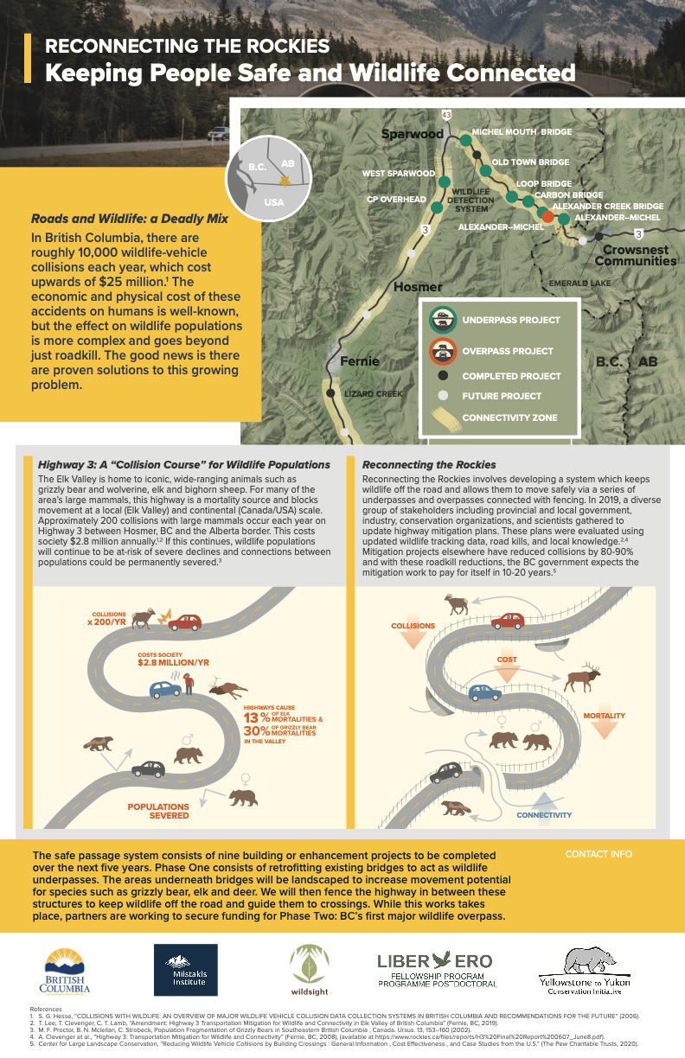

**Resources for Review:**

[www.transportecology.info](http://www.transportecology.info)

[www.Wildlifeandroads.org](http://www.Wildlifeandroads.org) (Utah-based)

[www.Roadsandwildlife.org](http://www.Roadsandwildlife.org) (Ontario-based)

[https://nrm.dfg.ca.gov/FileHandler.ashx?DocumentID=134712andinline](https://nrm.dfg.ca.gov/FileHandler.ashx?DocumentID=134712&inline)

<https://www1.pewtrusts.org/-/media/assets/2020/02/reducing-wildlife-vehicle-collisions-by-building-crossingscllcpew-005.pdf>

<https://arc-solutions.org/wp-content/uploads/2017/04/ARC-Special-Pub-Design-Parameters.pdf>

<https://www.codot.gov/programs/research/pdfs/2021-research-reports/state-highway-9-wildlife-mitigation-monitoring>

**Website resources**

<https://structurae.net/en/structures/aich-wildlife-crossing>

<https://structurae.net/en/structures/kikbeek-wildlife-crossing>

<https://structurae.net/en/structures/suchdol-nad-odrou-wildlife-crossing-d1>

<https://structurae.net/en/structures/eckartswiller-wildlife-bridge>

<https://structurae.net/en/structures/wildlife-overpass>

<https://structurae.net/en/structures/wiesenhagen-wildlife-crossing>

<https://structurae.net/en/structures/beelitz-wildlife-crossing>

<https://structurae.net/en/structures/grunbrucke-nietheim>

<https://structurae.net/en/structures/hainholz-green-bridge>

<https://structurae.net/en/structures/klein-flothe-wildlife-overpass>

<https://structurae.net/en/structures/teupitz-wildlife-crossing>

<https://structurae.net/en/structures/laarderhoogt-wildlife-crossing>

<https://structurae.net/en/structures/woeste-hoeve-wildlife-crossing>

<https://structurae.net/en/structures/terlet-wildlife-crossing>

<https://structurae.net/en/structures/rengelbur-wildlife-crossing>

<https://structurae.net/en/structures/horka-wildlife-crossing>

<https://structurae.net/en/structures/gancani-ecoduct>

<https://structurae.net/en/structures/mostje-ecoduct>

<https://structurae.net/en/structures/isenberg-tunnel>

<https://structurae.net/en/structures/stock-wildlife-crossing>